**Abstract**

Ecological communities vary in space at a variety of scales. In marine communities, dramatic changes in species composition can occur across a small spatial distance, resulting in communities that vary across seascapes. Through an experimental manipulation of seagrass (*Zostera marina*), we examined the processes that drive the abundance and distribution of *Smithora naiadum*, an epiphytic red alga, in *Zostera marina* meadows on the central coast of British Columbia. At, the shoot level, we hypothesized that *Smithora* could be controlled by invertebrate grazing or bacterial facilitation. Whereas, at the site level, we hypothesized that Smithora could be controlled by environmental factors leading to the recruitment and persistence of the epiphyte on seagrass shoots. We used a reciprocal transplant to investigate whether *Smithora* load was affected by shoot level characteristic, location (and associated environmental characteristics) or an interaction between . We found a significant interaction between source and final location on *Smithora* colonization. Uncolonized blades were colonized when placed in a high *Smithora* environment, while colonized blades did not lose their existing *Smithora* when moved to a *Smithora* free environment. Using illumina sequencing of bacterial DNA isolated from surface swabs of seagrass transplants, we found a significant difference between bacterial communities on shoots with and without *Smithora*. Further, we found that shoots with *Smithora* had a higher invertebrate abundance, indicating that *Smithora* is likely not grazer controlled. Our results suggest that seagrass associated bacterial and invertebrate communities could be altered by the colonization of epiphytic *Smithora,* or could be subject to the same spatial processes as *Smithora*. This research suggests potential drivers of epiphytic community composition in seagrass meadows. .

Introduction

What drives species variation across spatial scales continues to puzzle ecologists in a variety of ecosystems (Boström et al., 2006), and has consequences for the structure of biological communities (A. Driscoll, 2008; Levins, 1969). The concept of space becomes more interesting as we see variation at increasingly small scales where there is little or no apparent difference in biotic or abiotic conditions.

Seagrass are evolutionarily and structurally distinct from the macroalgae with which they co-occur, with macroalgae often growing epiphytically on seagrass shoots. Macroalgae have high growth rates, complex life cycles, and low structural complexity. Seagrass have slower growth rates than algae and vascular structure. While both the seagrass and epiphytic macroalgae contribute to the overall productivity of the seagrass ecosystem, in temperate *Zostera marina* meadows, epiphytic algae are usually more important as a food source for invertebrate grazers, while the seagrass is more important as habitat structure for resident species (Neckles et al., 1993). These ecological roles can vary depending on what macroalgae are present, the climate of the seagrass meadow, and number of trophic levels (Duffy paper, Mary’s 2 papers).

Due to these different ecological roles and life history strategies, both organisms respond differently to changes in the environment. Epiphytic algae have a rapid response to nutrient influxes, which can cause them to grow uncontrollably and outcompete seagrass for light (Borum, 1985; Moore et al., 1996; Tomasko and Lapointe, 1991). Seagrass meadows are currently in decline, in part due to rapid and excessive algal growth, particularly in the Northern Hemisphere (Orth et al. 2006).

In the Northeast Pacific, there is less evidence of eutrophication and overgrowth. There is a unique red algal epiphytic algae that can be prevalent in this region, *Smithora naiadum*. Studies on Smithora have indicated strong zonation patterns on surfgrass in the intertidal (Willcocks 1982). Smithora is not restricted to growing on seagrass: it can colonize blade-like substrates other than seagrass and grow in large amounts (Harlin 1973, ASU’s). Invertebrates have been shown to graze on *Smithora* (Carefoot 1973), however there is a lack of evidence for a strong top down effect of grazing on *Smithora* biomass. *Smithora* nearly covers the seagrass blade it colonizes, and has stiff basal cushions that attach to the blades surface, there is a lack of evidence for strong negative effects of *Smithora* on seagrass. Despite high biomass of *Smithora* on seagrass shoots, *Smithora* and seagrass appear to share space, making Smithora an ecologically interesting exception to the past knowledge of epiphytic algae on seagrass blades (Harlin 1975, Shin et al. 2008). .

Studies have investigated the processes that affect algae abundance on seagrass blades, but few have examined drivers of spatial variation within seagrass meadows. Studies have shown that there is both between- and within-meadow variation within epiphytic communities (Johnson et al., 2005; Lavery and Vanderklift, 2002; Prado et al., 2007; Saunders et al., 2003). Ecological theory suggests that a variety of mechanisms affect algal community composition, and what we see on the community level is an emergent property of these processes. However, the dominant processes are unclear, and with experimental manipulation we can attempt to determine what mechanisms control algal growth across seagrass meadows, and ultimately, their interactions with seagrass.

Algae and seagrass have different optimal nutrient, light, and temperature conditions (Harlin 1975), and so respond differently to stimuli. This uncoupling of niches has lead to many hypotheses for the high occurrence of epiphytic algae on seagrasses (Thorhaug & Hixon 1975, Harlin 1975, Horner 1987). When looking at epiphyte seagrass interactions it can be difficult to overcome the huge variation in environmental effects. Observational studies are insufficient to identify drivers of variation in epiphyte abundance because of the huge variation between sites (Borowitzka et al. 1990, Willcocks 1981). By manipulating algal abundance on seagrass in a single meadow changes in epiphyte abundance can be correlated with known differences between blades.

Both seagrass physical structure (length, width) and chemical content have been linked to variations in epiphyte abundance (Harline 1975). Horner showed that high epiphyte abundance at the tip of the seagrass plant is due to the exponential accumulation of epiphyte biomass with time (1987). Borowitzaka et al. found that epiphyte biomass increases with seagrass height (1990). Other studies have shown that seagrasses produce water soluble chemicals that inhibit the growth of microbes and epiphytic algae, and these phenolic extracts decrease in concentration as the blade scenesces near the tip (Harrison 1982). Horner proposes that epiphyte abundance is higher at seagrass tips because the algae have had more time to grow (1987). While chemical investigations into seagrass phenols suggest that higher epiphyte abundance at the tips of the blades is due to the lower ability of older seagrass to produce phenols that deter colonization by epiphytes.

The microbial communities of marine surfaces have been shown to be affected by both the physical shape of an object and the chemicals at the surface (Whal 1981). Extensive microbial surveys in seagrass meadows have shown that microbial communities vary significantly between seagrass beds (Meja et al. 2016). Seagrass phenols influence microbial communities (Harrison 1982, Vergeer & Develi 1997, Vergés et al. 2007). As a result, microbial communities can vary across meadow-wide scales and between blades. By examining microbial communities on seagrass blades with and without epiphytes we will have a better understanding of the microenvironment dispersing algal spores interact with. Our microbial analysis is part of an experiment manipulating the seagrass blade position, relative to epiphyte abundance, in a single meadow. Our experiment investigates microbial communities before and after epiphyte colonization. A before and after comparison gives a better understanding of blade level characteristics that could be driving variation in epiphyte abundance.

*Smithora naiadum* (hereafter, *Smithora*) is an ideal algal species for investigating controls of algal abundances in seagrass meadows. *Smithora* differs from other seagrass epiphytes because it is not an obligate epiphyte, grows from basal cushions (small mounds of stiff thallus structure) into lobed blades, and has no known diploid life stage. Ecologically it may be more nutritious compared to other epiphytic algae (due to a high fatty acid content) and play an important role in grazing food webs. Despite these unique attributes, Smithora’s wide distribution along the northwest coast, use as habitat for mesograzers, and it’s ability to dramatically cover a seagrass blade makes it a good algae to investigate because of its large effect on the seagrass community.

*Smithora* is a bladed red algal epiphyte that grows largely on *Zostera marina* and *Phyllospadix spp.*, but has also been shown to grow on other red algae and neutral substrates (Hansen, 1986; Harlin, 1973). *Smithora* is a prolific colonizer of seagrass meadows, and has a range from Baja California to Kodiak Island Alaska (Hansen, 1986; Scagel, 1986). *Smithora* reproduces asexually from monospores released from monostromatic bladed gametophytes that grow on seagrass (Hawkes, 1988a). In Choked Pass on Calvert Island, differences in *Smithora* cover on *Zostera marina* range from high to zero cover in less than a meter. This drastic change in abundance invites questions about the controls of algal colonization in seagrass meadows. Since *Smithora* has been shown to be an excellent colonizer of seagrass blades, a sudden absence of colonized blades is intriguing. Variation in *Smithora* spatial distribution could be driven by either a characteristic of the seagrass shoot’s location or a characteristic of the seagrass shoot itself.

Higher predation of invertebrate grazers by fish could be reducing the level of grazing on *Smithora* (Angeleen Olson, Unpublished). *Smithora* is a food source for amphipods and other epifaunal species. Thus, if higher grazing drives this decline in *Smithora* abundance, I expect to see higher grazer abundance where *Smithora* load is lower.

*Smithora*’s distribution amongst *Zostera* shoots could also be controlled by shoot-level characteristics. Microbial communities on the surface of seagrass blades have been shown to vary at small spatial scales (Mejia et al., 2016). Microbial communities can also vary with seagrass health, age, and phenol content (Egan et al., 2000). A bacterial community facilitates spore colonization, and it could be that *Smithora* colonization is correlated with a certain microbial community composition. By comparing the bacterial community on shoots with and without *Smithora*, I investigate a possible correlation between bacterial community composition and *Smithora* presence.

We examined the relative role of local-scale seagrass shoot level characteristics and site-level differences in environmental drivers on Smithora colonization and distribution on Z. marina. We performed a reciprocal transplant between two sites of high and low *Smithora* load. With this design, we tested two alternative hypotheses: 1) *Smithora* biomass would change to match the new site (indicating environmental control) and 2) *Smithora* abundance would not change following the transplant (indicating control by local shoot level characteristics). I predicted that *Smithora* abundance would experience higher grazing by invertebrates in the interior of the meadow. If the bacterial community is unique to a seagrass shoot and important for facilitating spore attachment, then certain shoots could repel colonization of *Smithora* even in a high *Smithora* environment. Since the transplant was reciprocal I was able to observe the interaction between location and shoot characteristics in both directions. The results of this experiment will further our understanding of the ecological processes that drive epifaunal community structure and the spatial distribution of *Smithora*.

**Methods**

**Methods and Materials**

**Study system and Organisms**

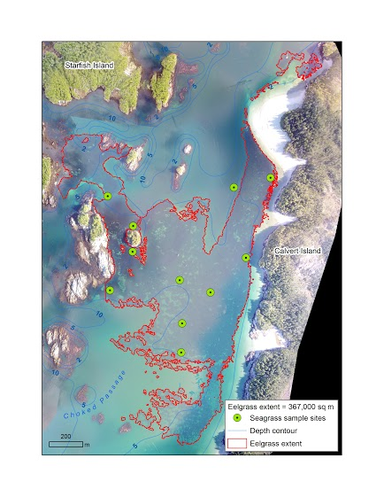

**Figure 1.** A map of Choked Pass seagrass meadow (outlined in red) on the west coast of Calvert Island red arrow indicates Wolf beach study site (Hakai geospatial team).

Choked Pass (Figure 1) is a narrow pass on the western side of Calvert Island on the central coast of British Columbia. The local seagrass species *Zostera marina* (eelgrass) grows in Choked Pass in a large continuous meadow approximately 367,000 square meters in area (Hakai geospatial team). A native red algal epiphyte species *Smithora naiadum* is abundant in Choked Pass but its spatial distribution varies throughout the meadow. At the Wolf Beach sampling site abundance is high at the edge of the meadow facing the rocky shore and then drops to 0 as you move into the meadow, sometimes in as little as 2m.

Typically, *Smithora* is more abundant at fringing sites and in high current areas but there are currently no maps of *Smithora*’s distribution in Choked Pass. Colonized blades can be 2m apart or 200m apart, but the distinction between *Smithora* colonized blades and un-colonized blades is very clear, making this an ideal study organism for epiphyte load. Choked Pass is a continuous seagrass meadow with gradients of high to low *Smithora* load, meaning that factors affecting *Smithora* load must vary at small distances and within the meadow. *Smithora* blades can grow on a surface in under 3 weeks, and due to their large size and stunning purple colour they can be easily spotted and quantified.

**Reciprocal transplant experiment**

In order to test whether *Smithora* colonization is a characteristic of the shoot or the environment, I conducted a reciprocal transplant experiment at the Wolf beach study site in Choked Pass. I transplanted 6 *Zostera marina* shoots from the edge of the meadow, with high *Smithora naiadum* load (approximately 80% cover) to the interior of the meadow (0% cover), as well as 6 shoots in the other direction (Figure 2). Herein I will refer to the shoots as edge or interior, edge shoots have high *Smithora* load and interior shoots have no *Smithora*. The edge and interior sites are both at the same depth, and on the same sandy substrate. Additionally, at each site I removed 6 control shoots from the substrate and attached them to the experimental platform. This was done to control for the effect of uprooting on *Smithora* abundance and bacterial community, herein these shoots are referred to as controls.

All 24 shoots were collected on July 9th and brought back to the lab where they were photographed and swabbed for bacterial community analysis. They were given an ID using flagging tape so that each shoot could be re-swabbed at the end of the experiment.

All shoots were randomly attached to one of two plastic netted platforms for each treatment (4 in total). The platforms were attached to rocks to keep the shoots on the sandy substrate and floating upright. The transplants were deployed using SCUBA on July 10th 2015 and collected on August 10th 2015. Two platforms were placed at the edge of the meadow surrounded by *Smithora* covered *Zostera marina* and two were placed in the interior of the meadow surrounded by *Smithora*-free *Zostera marina*. The interior platforms were approximately 5m into the meadow and perpendicular to the shore. Distances were counted using fin kicks.

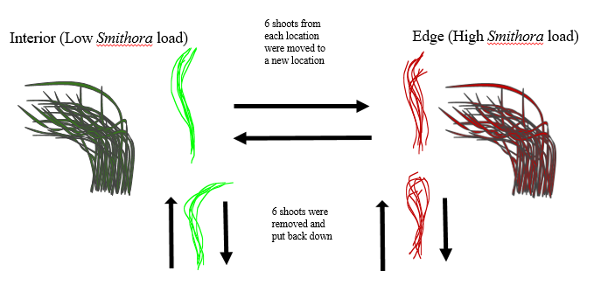

**Figure 2.** Basic design of the reciprocal transplant, red represents *Smithora* covered shoots, and green represents *Smithora*-free shoots.

Upon collection (August 10th) 2 ambient shoots were collected next to the transplant platforms. All shoots were brought back to the lab where they were processed and photographed. Processing of shoots involved scraping the blade with a microscope slide to remove all epiphytes, and shoot length and width were measured. Epiphytes were sorted into 2 categories: bryozoans and *Smithora*, following which they were weighed wet and then dried for 48 hours in a drying oven at 60°C, and then weighed again. The seagrass shoots were cut above the roots, so that only the space for colonization was considered, and the length and width of each shoot was measured. All invertebrate grazers were removed from the shoots upon collection.

**Bacterial Community Analysis**

Bacterial samples were taken from each shoot both before and after the transplant, as well as from ambient shoots collected at the time of transplant retrieval. An area halfway up the shoot that was free of *Smithora* was chosen for each shoot for bacterial sampling. This area was rinsed with filter sterilized seawater for 10 seconds, and then a Puritan® sterile swab was used to swab the area for ten seconds, avoiding any Smithora cushions. The swab was was stored in an individual sterile cryovial (VWR) and placed on ice for transport back to the lab, and were transferred to -80˚C for storage within 8 hours.

DNA was extracted from swabs and water filters using the MoBio PowerSoil®-htp 96 well DNA extraction kit (Carlsbad, CA) following the manufacturers recommended protocol. The V4 region of 16S rRNA in Bacteria and Archaea was targeted for amplification using redesigned versions of the primers *515f/806r* (Caporaso *et al.* 2012): *515f*: 5’–GTGYCAGCMGCCGCGGTAA–3’, *806r*: 5’–GGACTACNVGGGTWTCTAAT–3’. Forward primers were tagged with a 12bp Golay barcode to facilitate sample pooling. Each PCR contained 10µl of 5-Prime Master Mix, 1µl of each primer (final concentration = 0.2µM each), 0.5µl of peptide nucleic acid (PNA) chloroplast blocking primer (Lundberg *et al.* 2013; 0.2µM final concentration, purchased from PNA Bio Inc., Thousand Oaks CA), 2µl of DNA, and PCR grade water to a final volume of 25µl. PCR was carried out with an initial denaturation step at 94˚C for 3 minutes, followed by 25 cycles of denaturation at 94˚C for 45 seconds, PNA clamping at 75˚C for 60 seconds, primer annealing at 50˚C for 60 seconds, and extension at 72˚C for 90 seconds, with a final extension step of 72˚C for 10 minutes. PCR products were quantified using Quant-IT Pico Green® ds DNA Assay Kit (Life Technologies). Equal amounts (25ng) of each sample were pooled and then purified using the MoBio UltaClean® PCR clean-up kit. Pooled library quantitation and paired-end Illumina MiSeq sequencing (2 x 300bp) was carried out at the Integrated Microbiome Resource facility in the Centre for Genomics and Evolutionary Bioinformatics at Dalhousie University (Halifax, Canada).

Raw sequencing reads were demultiplexed using the Split Libraries function from the Quantitative Insights into Microbial Ecology (QIIME v.1.9) analysis pipeline (Caporaso *et al.* 2010b). Demultiplexed reads were then trimmed to a uniform length of 250bp using FastX Toolkit (http://hannonlab.cshl.edu/fastx_toolkit/), and /), and processed into operational taxonomic units (OTUs) using the Minimum Entropy Decomposition method (MEDs; Eren *et al.* 2015) as implemented in the Oligotyping microbial analysis software package (Eren *et al.* 2013). Briefly, MEDs perform *de novo* taxonomic clustering using Shannon Entropy to separate biologically meaningful patterns of nucleotide diversity from sequencing noise; the processed data are partitioned into phylogenetically homogeneous units (MED-nodes) for downstream bacterial diversity analyses. This analysis was carried out with the minimum substantive abundance parameter (-M) set at the default number of 90 reads. All other parameters were run with default settings; the maximum variation allowed per node (-V) was automatically set at three nucleotides.

Taxonomy was assigned to the resulting MED-nodes (hereafter referred to as operational taxonomic units; OTUs) using the RDP classifier v.2.2 (Wang *et al.* 2007) as implemented in the Assign Taxonomy function of QIIME v.1.9 retrained on the GreenGenes (gg_13_8) database (DeSantis *et al.* 2006). OTUs annotated to either chloroplast or mitochondrial sequences were removed as putative host contamination. Additional OTUs were removed if they occurred in only a single sample. Representative sequences for the remaining OTUs (n = 1984) were aligned with PyNAST v.1.2.2 (Caporaso *et al.* 2010a) using the GreenGenes 13_8 alignment as a template, and a tree was constructed using FastTree (Price *et al.* 2010) as implemented in QIIME v.1.9.

Bacterial diversity (richness and evenness) was calculated for each sample after rarefying to 5000 sequences/sample. We used the equitability metric for evenness and the non-parametric Chao1 index (Chao 1984) for richness, both implemented in QIIME. Chao1 estimates species abundance for each sample by adding a correction factor to the number of observed species in order to account for rare unsampled taxa. These attributes make Chao1 well suited for estimating diversity in microbial communities where the abundance of rare taxa means that samples are likely not representative of the entire community (Haegeman *et al.* 2013; Hughes *et al.* 2001). For these calculations, the bias-corrected version of Chao1 was implemented using Qiime v.1.9. Bacterial species evenness was calculated for each sample using the equability index as implemented in Qiime v.1.9.

In order to quantify differences in bacterial assemblage among groups (beta diversity), a dissimilarity matrix was constructed using unweighted UniFrac distances (Lozupone & Knight 2005) on rarefied data (5000 sequences/sample) using QIIME v.1.9. Beta-diversity patterns were visualized with Principal Coordinates plots created in PRIMER E v. 6 (Clarke & Gorley 2006)

Sequence data and MiMARKs compliant metadata are deposited at the European Bioinformatics Institute, accession number (XXXXXXXX).

This determined the bacterial species richness on each seagrass shoot. In addition to swabs from experiment, control, and ambient shoots, swabs from 4 different *Smithora* blades were included in the analysis.

**Invertebrate Grazer Community Analysis**

Three 0.25m X 0.25m *Zostera marina* quadrats were collected from the interior and edge at the Wolf Beach study site in early June. Three quadrats were heavy with *Smithora* (on the edge) while the other three had no *Smithora* load (from the interior). These quadrats were processed by a standardized processing protocol similar to Whippo (2013), the only difference being that diatoms were filtered out of the water and weighed. All shoots were scraped, removing all macro epiphytes, and the number of shoots in the quadrat was counted. Algal species and bryozoans were weighed separately. *Zostera marina* shoots were measured, and weighed wet and dry. All invertebrates found on the shoots were removed and preserved with 95% ethanol for diversity analysis. All grazers from one quadrat were placed in the same ethanol tube.

Invertebrate samples were filtered through multiple mesh sizes to isolate the different size classes, and then classified to the closest possible taxonomic grouping. Every invertebrate from the ethanol tube was recorded. Due to the cryptic diversity of gammaridian amphipods these organisms were only identified to order. Anemones found were also difficult to identify to species, therefore, they were also identified to order. Otherwise, every invertebrate in each quadrat was classified to as specific a grouping as possible, see Appendix 1 for exact groupings.

**Table 1.** Showing sample sizes for the experiments and treatment levels. Please note Edge and Interior refer to high and low *Smithora* load respectively, as well as their position in the seagrass meadow.

**Test and Treatments Measurement level Sample Size**

*Smithora Biomass & Microbial Community*

Edge Experiment After Shoot 3

Interior Experiment After Shoot 3

Edge Control After Shoot 5

Interior Control After Shoot 4

Edge Ambient After Shoot 2

Interior Ambient After Shoot 2

*Just Microbial Community*

Edge Experiment Before Shoot 3

Interior Experiment Before Shoot 3

Edge Control Before Shoot 5

Interior Control Before Shoot 4

*Smithora* blades Blades 4

*Grazer Community*

Interior June Quadrat 3

Edge June Quadrat 3

**Statistical Analysis**

To analyze the results from the reciprocal transplant experiment a log linear analysis was done using a three variable contingency table (Appendix 1). Since the absence or presence of *Smithora* was the primary question, frequency counts of present/absence on control/experiment shoots, at the two locations were used as counts in the table. The table was analyzed in VASSAR stats (Lowry R).

Bacterial community data was analyzed in the Vegan 2.3-4 computing package in R 3.2.4 was used (Okansen et al. 2016). All community comparisons were comparing communities before and after transplant and with and without *Smithora*. Each OTU (operational taxonomic unit) that was identified using illumina sequencing was counted as a taxonomic grouping that was checked using BLAST (Basic Local Alignment Search Tool). What rarefaction level was used for analysis? One sample from the interior controls that had extremely low sequence reads was removed from the analysis. Fisher-alpha diversity was calculated for each shoot bacterial community. Fisher-alpha values for control and experiment shoots were analyzed separately. A Shapiro-Wilks test showed that the data fit a normal distribution. A paired t-test was used to compare shoot level diversity before and after transplant.

Non-metric Multi Dimensional Scaling (NMDS) plots were used to visualize bacterial community dissimilarity. We used the Bray-Curtis metric which takes relative abundance as well as presence/absence of taxa into account ~~. because of its focus on community dissimilarity and its emphasis of compositional changes within a community~~ (Anderson and Santana-Garcon, 2015). A PERMANOVA (Permutational Analysis of Variance) was used to test the effect of *Smithora* presence (with transplant time as a block), and transplant on community composition (with *Smithora* presence as a block). This was to account for the fact that both transplant and *Smithora* presence could have altered bacterial community composition co-currently.

For the invertebrate grazer analyses, community rank abundance plots fit a log distribution and there was variation in sample size which made the fisher alpha diversity calculation the best choice for comparing diversity between shoots. A shapiro-wilks test showed that the diversity values were normally distributed. A one-way linear model was used to make comparisons between sites with high and low *Smithora*. Gammaridian amphipod abundance was compared between sites using a linear model.

**Results**

**Reciprocal Transplant**

From the three-way contingency table of *Smithora* presence vs. absence I found a significant interaction between source (where the transplant came from) and final location (where it was relocated to) on *Smithora* colonization. Figure 3 is used to illustrate the interaction, but does not represent the way the interaction was proven, the contingency table used to calculate the log linear analysis can be found in the attached appendix. Since frequencies (N = 15) were used to analyze the results, Table 2 shows the effect of the three variables in the contingency table on these frequencies. For a more detailed explanation of this statistical test please see the appendix.

**Table 2.** Breakdown of summary statistics for log linear analysis of the three-way contingency table. Type refers to experiment or control shoot, *Smithora* refers to presence or absence of *Smithora*, and location refers to the final location of the transplant.

|  |  |  |  |
| --- | --- | --- | --- |
| Test | G2 | Df | P |
| Type\**Smithora*\* Location | 17.42 | 4 | 0.0016** |
| Type\**Smithora* | 5.02 | 1 | 0.0251** |
| Type *Location | 0.02 | 1 | 0.8875 |
| Location\**Smithora* | 7.84 | 1 | 0.0051 |
| Type\**Smithora* with location removed | 9.56 | 2 | 0.0084** |
| Type*Location with *Smithora* removed | 4.56 | 2 | 0.1023 |
| Location\**Smithora* with type removed | 12.38 | 2 | 0.002** |

**Figure 3**. Reciprocal transplant graph illustrating the effect of transplant on *Smithora* biomass (g). The blue line represents shoots that were moved from the interior to the edge. The red line represents shoots that were moved from the edge to the interior. Circles indicate biomass from shoots that were collected from the meadow when the transplants were collected, representing ambient *Smithora* biomass. Triangles represent final biomass from transplanted shoots. The colour blue represents from the interior and the colour red represents from the edge.

**Bacterial Community**

A total of 307 bacterial OTU’s were identified. Fisher’s alpha diversity values were calculated for every shoot community. A paired t-test showed that transplanting the shoot increased fisher’s alpha diversity within controls (t = -3.2414, df = 4, p-value = 0.032, N = 9) and within shoots that were transplanted to new locations (t = -4.4887, df = 5, p-value = 0.0065, N = 6)

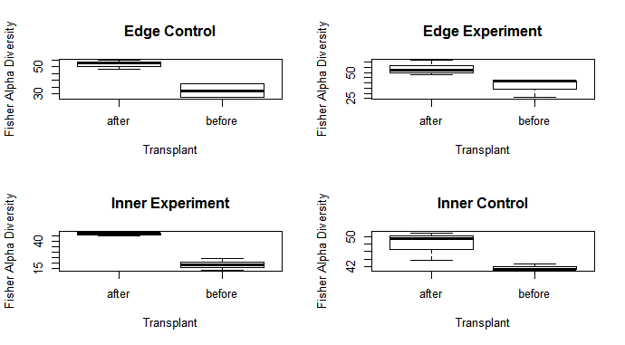

**Figure 4**. Box plots of fisher alpha diversity values for control and experiment shoots before and after transplant. This illustrates that bacterial communities changed on each shoot after it was transplanted, even when it did not change location.

Additionally, bacterial community composition differed significantly between shoots with and without *Smithora*. *Smithora* presence was correlated with a particular community composition whereas final location and the interaction between *Smithora* and final location had no significant effect (Table 1). Please note the PERMANOVA that was used to analyze the effect of *Smithora* presence on bacterial community looked within shoots before and after transplant, a total of 27 seagrass shoots were used in this analysis.

**Table 3**. Summary of PERMANOVA results for the test of significance of variables on bacterial community composition on transplanted seagrass blades when communities were blocked within before and after transplant.

|  |  |  |  |
| --- | --- | --- | --- |
| Test | Degrees of freedom | F-value | P value |
| *Smithora* (presence/absence) | 1 | 2.95 | 0.0050** |
| Location | 1 | 1.16 | 0.1568 |
| Source | 1 | 0.71 | 0.7081 |
| *Smithora*\*Location | 1 | 0.4854 | 0.4854 |

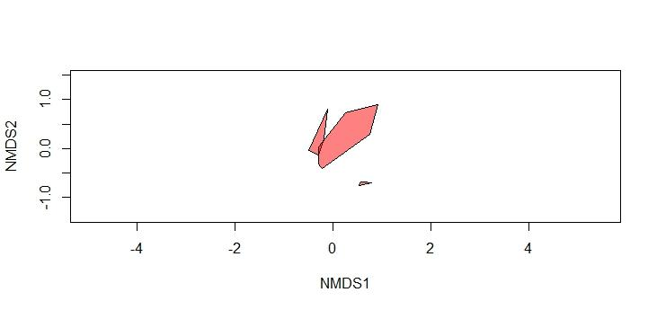

**Figure 5**. NMDS plot displaying the higher similarity between bacterial communities from shoots with *Smithora* vs. without *Smithora* and *Smithora* itself, stress is displayed on the plot.

The action of transplanting the seagrass itself also had an effect on bacterial community, as well as the interaction between source location and transplanting.

**Table 4**. Summary of PERMANOVA results Time refers to whether the community was before or after transplant. Shoot communities were blocked by *Smithora* presence/absence (N = 27).

|  |  |  |  |
| --- | --- | --- | --- |
| Test | Degrees of freedom | F-value | P value |
| Time | 1 | 5.17 | 0.0001** |
| Location | 1 | 2.12 | 0.0685 |
| Source | 1 | 2.35 | 0.3468 |
| Time*Source | 1 | 3.92 | 0.0008** |
| Time*Location | 1 | 1.00 | 0.5222 |
| Location*Source | 1 | 1.02 | 0.5780 |

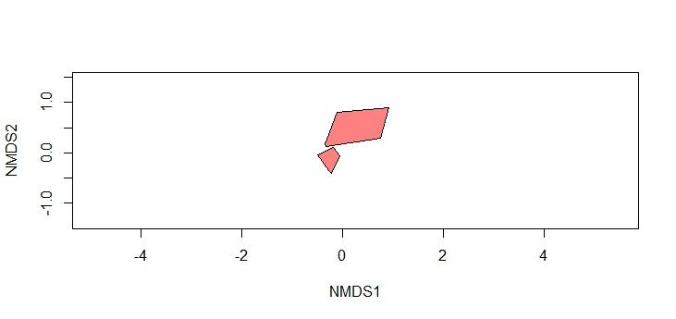

**Figure 6.** NMDS plot demonstrating the higher similarity between bacterial communities after transplant vs. before transplant, stress is 0.065 (before is more spread out polygon).

**Grazer Community Analysis**

From the 6 *Zostera marina* quadrats I analyzed I found that *Smithora* presence was correlated with higher grazer diversity when gammaridian amphipods were removed from the analysis (p = 0.03854 , df = 1 , F = 9.2198). As well as a higher gammaridian amphipod abundance at edge sites (p = 0.0005631, df = 1, F = 99.898).

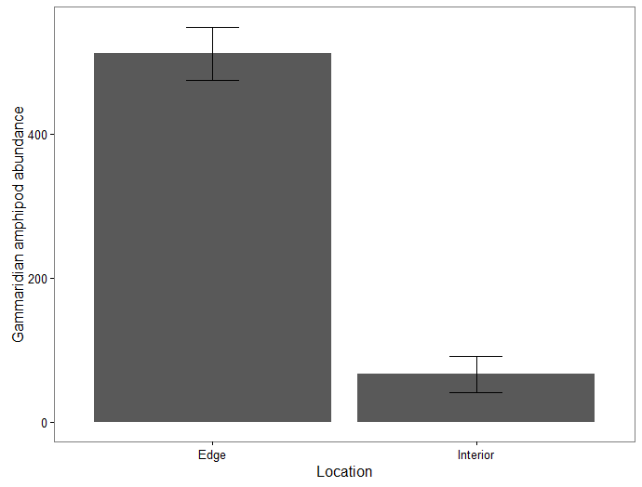

**Figure 7.** A comparison of average amphipod abundance of quadrats from the two transplant locations (Edge = high *Smithora*, Interior = no *Smithora*), error bars show standard error.

**Discussion**

**Summary of results for reciprocal transplant**

Since there was no significant loss of *Smithora* when shoots were moved to a *Smithora* free zone I can infer that *Smithora*’s absence in the interior of the meadow is likely not due to grazing pressures by the invertebrates I identified. Shoots did not lose their *Smithora* after 1 month of being in a *Smithora* free environment. This indicates strongly that there is no change in an environmental variable between the edge and interior that prevents *Smithora* recruitment and settlement. Conditions may or may not be better at the edge for *Smithora*, but it can survive in the interior even though it is not present at that location. The ability of *Smithora* to grow in new locations when it is manually transplanted indicates that it could be experiencing dispersal limitation in Choked Pass.

When shoots were moved to the edge from the interior they were colonized with *Smithora*. This is likely due to *Smithora*’s continual release of spores (Hawkes, 1988b). The blades grow from a basal cushion and produce haploid spores from monostromatic tissue (Hawkes, 1988b). *Smithora* is known as a prolific colonizer and its high growth and colonization in a three-week time frame is not surprising. The fact that clean transplants were colonized indicates that shoots were *Smithora* free because of a lack of spores rather than a shoot level characteristic-and this could mean that *Smithora* is experiencing dispersal limitation.

Many models exist for explaining how currents and wave motions drive dispersal of algal spores (Gaylord et al., 2002). However in general these models show that there is huge variation in dispersal distances of species, and they are difficult to predict (Gaylord et al., 2002). Choked pass is a high current area, it could be that the current is so strong that spores drift at an angle, and are just swept off the meadow entirely. The speed of spreading is also related to the generation time of the species, as species can disperse small distances, grow and then release spores again (Norton 1992). *Smithora* individuals might take a while to develop before they can release spores, and the blades from which the spores release die back in the summer, limiting the dispersal of *Smithora* deeper into the meadow. A combination of life history and wave action could be limiting *Smithora* spread in Choked Pass.

The sexual stage of *Smithora* is unknown. However there is evidence for its existence (Hawkes, 1988b). The *Zostera marina* meadow is adjacent to a rocky intertidal habitat at the Wolf Beach site. *Smithora* is often found in the intertidal on *Phyllospadix spp*. and this plant has drifted into samples with *Smithora* attached. We also found *Smithora* on artificial seagrass units that were placed along the edge of the site. *Smithora* individuals are coming from somewhere, and it could be other haploid individuals or the diploid stage of the algae. Whether *Smithora* is dispersing as spores from a diploid crust or from blades already growing, limited dispersal from the rocky shore could be occurring. This suggests that dispersal could be highly important in dictating epiphyte community structure. Due to *Smithora*’s presence being influenced strongly by a change in location, it seems likely that we do not have *Smithora* communities in the interior of the meadow simply because the spores haven’t made it there yet, and this could be further tested by mapping seasonal spreading distribution.

**Bacterial Community Analysis**

The significant effect of transplant on bacterial diversity hints at a complex relationship between seagrass health, algae, and bacterial community. *Zostera marina* possesses the ability to produce phenols that act as antioxidants and chemically defends against epiphytic colonizers (Harder, 2008). In response to shading *Zostera marina* has been shown to increase phenol content to deal with oxidative stress (Silva et al., 2013). Bacterial community is then affected by this change in phenol content (Holmström et al., 2002b). In Figure 3 we see that bacterial diversity increases significantly after transplant. Removing a seagrass shoot from its root system is a stressful event for the plant. Moving a shoot could compromise its ability to produce protective phenols and allow for more species of bacteria to colonize the shoot. The fact that initial and final diversities changed with the presence of *Smithora* suggests that *Smithora* itself could be influencing the bacterial diversity in a similar way that physical stress does.

Bacterial community is very responsive to shoot level changes, and was significantly correlated with transplant and spore colonization. I believe that *Smithora* colonization itself could be altering the blade level community, rather than a specific bacterial community existing at the edge of the meadow that allows spores to colonize. Further evidence of bacterial community change in response to blade level conditions is the change in composition observed when the control seagrass was removed and reattached. Simply the action of removing a blade from the substrate was sufficient to cause a significant change in bacterial community composition. Again the production of phenols likely changed, and transplanted shoots looked like they were degrading compared to ambient shoots.

However, there is still a possibility that bacterial community could be promoting *Smithora* colonization. *Ulva* spores (a green algae species) have been shown to respond to chemical cues produced by a specific bacterial community (Joint et al., 2002). We see a significant correlation between *Smithora* presence and bacterial community composition, and we could be observing chemical communication between prokaryotes and eukaryotes. There is also the possibility that the detrimental impacts of shading caused by *Smithora* are changing the chemical environment of the blade and promoting a different bacterial community. Based on *Smithora*’s ability to colonize various substrates, and the colonization of clean blades that were moved to the high *Smithora* environment, I suggest that bacteria community does not determine *Smithora* colonization, rather *Smithora* colonization alters bacterial community.

Smithora colonization is correlated with community change at the bacterial level and this has implications for the larger seagrass community. Microbial communities in seagrass sediments have been connected to overall shoot health (Milbrandt et al. 2008), however this has yet to be shown conclusively with blade level microbial communities. Bacterial shifts on the surface of the blade could be linked to seagrass degradation, epiphytic colonization, or the presence of wasting disease.

**Grazer Community Analysis**

The increase in amphipod abundance correlated with *Smithora* presence suggests that *Smithora* is likely not grazer controlled. Invertebrate herbivores are widely known to eat macroalgae in seagrass meadows (Heck and Valentine, 2006). Amphipods have also been shown to consume a large amount of microalgae (Cruz-Rivera and Hay, 2000). The high fatty acid content makes Smithora very nutritious and epiphytic grazers turn red from eating it (Oregon university). I expected to see some grazer control of *Smithora* abundance, because of previous evidence for predator-grazer-epiphyte trophic cascades in *Zostera marina* meadows (Amundrud et al., 2015; Duffy et al., 2015)(Duffy et al., 2015)(Duffy et al., 2015).

Recent studies in the Choked Pass seagrass meadow have shown that juvenile rockfish use the meadow edge frequently as habitat (Angeleen Olson, Unpublished). Juvenile rockfish eat amphipods and I thought that I was witnessing a trophic cascade because of the high *Smithora* load in this edge habitat. I expected to find higher grazer abundance in areas of seagrass where *Smithora* wasn’t present. However, amphipods had a dramatic increase in abundance where *Smithora* load was high (Cruz-Rivera and Hay, 2000). This suggests that top-down control is not what is causing the dramatic decline in *Smithora* from the edge to the interior of the seagrass meadow. *Smithora* could be providing a food source to amphipods and also sheltering them from predation, which would be influencing the community structure from the bottom up.

**Conclusion**

In conclusion three layers of the epifaunal community of *Zostera marina* were found to vary in space. *Smithora* varies in abundance from the edge to the interior of the seagrass meadow, possibly through dispersal limitation. Bacterial and invertebrate communities vary significantly on shoots with and without *Smithora*. Whether these variations in communities with *Smithora* are a result of species interactions or spatial processes remains unknown. Edge effects in seagrass meadows are likely playing a crucial role that needs to be further investigated.

Epibiotic communities on seagrass blades represent an intriguing system to use small scale processes to explain large scale patterns. Species interactions on a single blade when multiplied over every shoot in a meadow can have dramatic effects. Understanding the drivers of changes in seagrass epiphytic community structure will help predict large scale changes in the seagrass ecosystem.

**Literature Cited**

A. Driscoll, D. (2008). The frequency of metapopulations, metacommunities and nestedness in a fragmented landscape. *Oikos*, *117*(2), 297–309. https://doi.org/10.1111/j.2007.0030-1299.16202.x

Amundrud, S. L., Srivastava, D. S., & O’Connor, M. I. (2015). Indirect effects of predators control herbivore richness and abundance in a benthic eelgrass (Zostera marina) mesograzer community. *The Journal of Animal Ecology*, *84*(4), 1092–1102. https://doi.org/10.1111/1365-2656.12350

Anderson, M. J., & Santana-Garcon, J. (2015). Measures of precision for dissimilarity-based multivariate analysis of ecological communities. *Ecology Letters*, *18*(1), 66–73. https://doi.org/10.1111/ele.12385

Borum, J. (1985). Development of epiphytic communities on eelgrass (Zostera marina) along a nutrient gradient in a Danish estuary. *Marine Biology*, *87*(2), 211–218.

Boström, C., Jackson, E. L., & Simenstad, C. a. (2006). Seagrass landscapes and their effects on associated fauna: A review. *Estuarine, Coastal and Shelf Science*, *68*(3–4), 383–403. https://doi.org/10.1016/j.ecss.2006.01.026

Cruz-Rivera, E., & Hay, M. E. (2000). The Effects of Diet Mixing on Consumer Fitness: Macroalgae, Epiphytes, and Animal Matter as Food for Marine Amphipods. *Oecologia*, *123*(2), 252–264.

Duffy, J. E., Reynolds, P. L., Boström, C., Coyer, J. A., Cusson, M., Donadi, S., … Stachowicz, J. J. (2015). Biodiversity mediates top–down control in eelgrass ecosystems: a global comparative-experimental approach. *Ecology Letters*, *18*(7), 696–705. https://doi.org/10.1111/ele.12448

Egan, S., Thomas, T., Holmström, C., & Kjelleberg, S. (2000). Phylogenetic relationship and antifouling activity of bacterial epiphytes from the marine alga Ulva lactuca. *Environmental Microbiology*, *2*(3), 343–347. https://doi.org/10.1046/j.1462-2920.2000.00107.x

Gaylord, B., Reed, D. C., Raimondi, P. T., Washburn, L., & McLean, S. R. (2002). A Physically Based Model of Macroalgal Spore Dispersal in the Wave and Current-Dominated Nearshore. *Ecology*, *83*(5), 1239–1251. https://doi.org/10.1890/0012-9658(2002)083[1239:APBMOM]2.0.CO;2

Hansen, G. I. (1986). A newly discovered host of the sea-grass epiphyte Smithora naiadum (Bangiophyceae, Rhodophyta). *Canadian Journal of Botany*, *64*(4), 900–901.

Harder, T. (2008). Marine epibiosis: concepts, ecological consequences and host defence. Retrieved from http://link.springer.com/chapter/10.1007/7142_2008_16

Harlin, M. M. (1973). “Obligate” Algal Epiphyte: Smithora Naiadum Grows on a Synthetic Substrate1. *Journal of Phycology*, *9*(2), 230–232. https://doi.org/10.1111/j.1529-8817.1973.tb04085.x

Hawkes, M. W. (1988a). Evidence of sexual reproduction in *Smithora naiadum* (Erythropeltidales, Rhodophyta) and its evolutionary significance. *British Phycological Journal*, *23*(4), 327–336. https://doi.org/10.1080/00071618800650361

Hawkes, M. W. (1988b). Evidence of sexual reproduction in Smithora naiadum (Erythropeltidales, Rhodophyta) and its evolutionary significance. *British Phycological Journal*, *23*(4), 327–336. https://doi.org/10.1080/00071618800650361

Heck, K. L., & Valentine, J. F. (2006). Plant–herbivore interactions in seagrass meadows. *Journal of Experimental Marine Biology and Ecology*, *330*(1), 420–436.

Holmström, C., Egan, S., Franks, A., McCloy, S., & Kjelleberg, S. (2002). Antifouling activities expressed by marine surface associated Pseudoalteromonas species. *FEMS Microbiology Ecology*, *41*(1), 47–58. https://doi.org/10.1016/S0168-6496(02)00239-8

Johnson, M. P., Edwards, M., Bunker, F., & Maggs, C. A. (2005). Algal epiphytes of Zostera marina: Variation in assemblage structure from individual leaves to regional scale. *Aquatic Botany*, *82*(1), 12–26.

Joint, I., Tait, K., Callow, M. E., Callow, J. A., Milton, D., Williams, P., & Cámara, M. (2002). Cell-to-Cell Communication Across the Prokaryote-Eukaryote Boundary. *Science*, *298*(5596), 1207–1207. https://doi.org/10.1126/science.1077075

Lavery, P., & Vanderklift, M. (2002). A Comparison of Spatial and Temporal Patterns in Epiphytic Macroagal Assemlages of the Seagrasses Amphibolis and Posidonia Coriacea. Retrieved from http://ro.ecu.edu.au/ecuworks/4175/

Levins, R. (1969). Some demographic and genetic consequences of environmental heterogeneity for biological control. *Bulletin of the Entomological Society of America*, *15*(3), 237–240.

Mejia, A. Y., Rotini, A., Lacasella, F., Bookman, R., Thaller, M. C., Shem-Tov, R., … Migliore, L. (2016). Assessing the ecological status of seagrasses using morphology, biochemical descriptors and microbial community analyses. A study in Halophila stipulacea (Forsk.) Aschers meadows in the northern Red Sea. *Ecological Indicators*, *60*, 1150–1163. https://doi.org/10.1016/j.ecolind.2015.09.014

Moore, K. A., Neckles, H. A., & Orth, R. J. (1996). Zostera marina (eelgrass) growth and survival along in the lower Chesapeake Bay. *Mar. Ecol. Prog. Ser*, *142*, 247–259.

Neckles, H. A., Wetzel, R. L., & Orth, R. J. (1993). Relative effects of nutrient enrichment and grazing on epiphyte-macrophyte (Zostera marina L.) dynamics. *Oecologia*, *93*(2), 285–295. https://doi.org/10.1007/BF00317683

Prado, P., Alcoverro, T., Martínez-Crego, B., Vergés, A., Pérez, M., & Romero, J. (2007). Macrograzers strongly influence patterns of epiphytic assemblages in seagrass meadows. *Journal of Experimental Marine Biology and Ecology*, *350*(1–2), 130–143. https://doi.org/10.1016/j.jembe.2007.05.033

Saunders, J. E., Attrill, M. J., Shaw, S. M., & Rowden, A. A. (2003). Spatial variability in the epiphytic algal assemblages of Zostera marina seagrass beds. *Marine Ecology Progress Series*, *249*, 107–115.

Scagel, R. F. (1986). *A synopsis of the benthic marine algae of British Columbia, northern Washington and southeast Alaska*. Dept. of Botany, University of British Columbia.

Silva, J., Barrote, I., Costa, M. M., Albano, S., & Santos, R. (2013). Physiological Responses of Zostera marina and Cymodocea nodosa to Light-Limitation Stress. *PLOS ONE*, *8*(11), e81058. https://doi.org/10.1371/journal.pone.0081058

Tomasko, D. A., & Lapointe, B. E. (1991). Productivity and biomass of Thalassia testudinum as related to water column nutrient availability and epiphyte levels: field observations and experimental studies. *Marine Ecology Progress Series. Oldendorf*, *75*(1), 9–17.

In new paragraphs, will add and format tomorrow

Carefoot, T. H. (1973). Feeding, food preference, and the uptake of food energy by the supralittoral isopod Ligia pallasii. *Marine Biology*, *18*(3), 228-236.

Harrison, P. G. (1982). Control of microbial growth and of amphipod grazing by water-soluble compounds from leaves of Zostera marina. *Marine Biology*, *67*(2), 225-230.

Vergeer, L. H., & Develi, A. (1997). Phenolic acids in healthy and infected leaves of Zostera marina and their growth-limiting properties towards Labyrinthula zosterae. *Aquatic Botany*, *58*(1), 65-72.

Borowitzka, M. A., Lethbridge, R. C., & Charlton, L. (1990). Species richness, spatial distribution and colonisation pattern of algal and invertebrate epiphytes on the seagrass Amphibolis griffithii. *Marine ecology progress series. Oldendorf*, *64*(3), 281-291.

Willcocks, P. A. (1982). Colonization and distribution of the red algal epiphytes Melobesia mediocris and Smithora naiadum on the seagrass Phyllospadix torreyi. *Aquatic Botany*, *12*, 365-373.

Horner, S. M. J. (1987). Similarity of epiphyte biomass distribution on Posidonia and artificial seagrass leaves. *Aquatic botany*, *27*(2), 159-167.

Harlin, M. M. (1975). Epiphyte—host relations in seagrass communities. *Aquatic Botany*, *1*, 125-131.

Thorhaug, A., & Hixon, R. (1975). Revegetation of Thalassia testudinum in a Multiple-Stressed Estuary, North Biscayne Bay, Florida. In *Proceedings for Second Annual Conference on the Restoration of Coastal Vegetation in Florida May 17, 1975, Hillsborough Community College, Tampa, Florida, p 12-27. 2 fig, 1 tab, 12 ref.*.

Vergés, A., Becerro, M., Alcoverro, T., & Romero, J. (2007). Experimental evidence of chemical deterrence against multiple herbivores in the seagrass Posidonia oceanica. Marine Ecology Progress Series 343 : 107-114.

Michael, T. S., Shin, H. W., Hanna, R., & Spafford, D. C. (2008). A review of epiphyte community development: surface interactions and settlement on seagrass. *Journal of Environmental Biology*, *29*(4), 629-638.

Milbrandt, E. C., Greenawalt-Boswell, J., & Sokoloff, P. D. (2008). Short-term indicators of seagrass transplant stress in response to sediment bacterial community disruption. *Botanica Marina*, *51*(2), 103-111.